**LIBRARY MANAGEMENT SYSTEM**

A MINI PROJECT REPORT

Submitted By

RITHVIK M - (220701227)

In partial fulfillment for the award of the degree of

BACHELOR OF ENGINEERING

IN

COMPUTER SCIENCE AND ENGINEERING

RAJALAKSHMI ENGINEERING COLLEGE (AUTONOMOUS) THANDALAM

CHENNAI-602105 2024-2025

**Table of Contents**

1. Introduction
2. Abstract
3. Problem Statement
4. Objectives
5. System Requirements and Scope
6. Software Description and Key Features
7. Programming Languages and Technologies Used
8. Code Implementation
9. Output(UI)

10.Results and Analysis

11.Conclusion

**1. Introduction**

The library industry is increasingly adopting digital solutions to improve user experiences and streamline operations. Many traditional libraries rely on manual processes for book checkouts, catalog management, and user feedback collection, leading to inefficiencies and errors. As a result, patrons often face delays in finding books or experience difficulty in accessing real-time information, while library staff struggle with limited insights into book usage and inventory management. This report discusses a **Library Management System (LMS)** that integrates online book checkouts, digital catalogs, real-time analytics, and feedback mechanisms to address these challenges. By automating key tasks, the LMS aims to enhance user satisfaction, improve inventory control, and optimize library operations.

**2. Abstract**

This **Library Management System (LMS)** is designed to modernize and optimize library operations. The system focuses on three main areas: book management, user experience, and data-driven insights. Key features include the ability to manage book checkouts and returns, categorize and update the book catalog, and offer a search function for users to easily find available books. The system also includes real-time analytics to track book popularity, borrowing trends, and user feedback. By automating routine tasks, improving inventory management, and enhancing user experience, the LMS aims to increase operational efficiency and provide valuable insights for better library management.

**3. Problem Statement**

The traditional approach to library management presents several challenges, primarily due to outdated manual methods. The main issues identified include:

1. **Manual Cataloging**: Relying on paper-based systems or spreadsheets to track books is inefficient and prone to errors. This can result in missing or duplicated entries, difficulty in locating books, and an overall lack of organization.

2. **Limited User Access**: Without an integrated digital catalog, library users often face difficulty in checking the availability of books or navigating the collection. This lack of easy access leads to delays and inefficiencies for both users and staff.

3. **Inefficient Inventory Management**: Manual methods do not provide real-time tracking of borrowed books, overdue items, or stock levels, making it challenging to manage inventory and ensure popular books are readily available.

These challenges highlight the need for a modern, automated Library Management System (LMS) to efficiently manage collections, improve user experience, and streamline library operations.

**4. Objectives**

The Library Management System (LMS) aims to meet the following objectives:

* **Streamline Book Management**: Provide an efficient platform for users to manage book checkouts, returns, and catalog updates, reducing the reliance on manual methods and minimizing errors.
* **Visualize Library Data**: Offer interactive search features and reports to help users understand borrowing trends, book popularity, and user engagement at a glance.
* **Enhance User Experience**: Enable patrons to easily find, reserve, and access books through a user-friendly interface.
* **Provide Actionable Insights**: Generate detailed reports and analytics on book usage, inventory levels, and user feedback to assist library staff in making informed decisions and optimizing library operations.

**5. System Requirements and Scope**

**Functional Requirements**

1. **Book Management**: Allow users to add, edit, and delete books from the catalog, including details such as title, author, genre, and availability status.

2. **Book Checkout and Return**: Enable users to borrow and return books, tracking due dates and overdue items automatically.

3. **Search and Filtering**: Provide an efficient search feature that allows users to find books by title, author, genre, or availability status.

4. **Reporting System**: Generate reports on book usage, overdue items, and user activity to help library staff manage inventory and user engagement.

**Non-Functional Requirements**

1. **Performance**: The system should handle multiple users accessing and updating the catalog simultaneously, providing fast responses even with large volumes of data.

2. **Security**: Ensure user data, such as borrowing history and personal information, is encrypted and compliant with data protection regulations.

3.**Usability**: Offer a simple, user-friendly interface for both patrons and staff, ensuring ease of navigation across devices.

**Scope**

The Library Management System focuses on core functionalities such as catalog management, book checkout and return, user management, and generating usage reports. It does not include advanced features like integration with external book suppliers, digital media management, or advanced accounting features.

**6.Software Description and Key Features**

The **Library Management System (LMS)** includes various features to address both user needs and library operational efficiency:

**Book Management**: Users can add, edit, and delete books from the catalog, with details such as title, author, genre, availability status, and location. This ensures an up-to-date and organized catalog.

**Book Checkout and Return**: Patrons can easily borrow and return books. The system tracks due dates and overdue items, sending automatic reminders to ensure timely returns.

**Search and Filtering**: A robust search feature allows users to quickly find books by title, author, genre, or availability status. This improves the overall user experience by reducing the time spent searching for books.

**Interactive Reports**: The system generates detailed reports on book usage, overdue items, and user activity. These insights help library staff manage inventory, monitor usage patterns, and make informed decisions to improve library services.

**7. Programming Languages and Technologies Used**

**Frontend**: React and Bootstrap are used to build responsive, user-friendly interfaces and dynamic content rendering, ensuring an intuitive user experience across devices.

**Backend:** Node.js is employed to handle server-side operations, data processing, and logic, ensuring efficient communication between the front-end and the database.

**Database**: MongoDB is utilized for efficient data storage, supporting records such as book details, user data, and transaction histories (for book checkouts, returns, etc.).

**APIs and Libraries**: Third-party libraries and APIs are integrated for features such as data visualization, authentication, and seamless interaction with external services (e.g., email reminders for overdue books).

**8. Output (UI)**

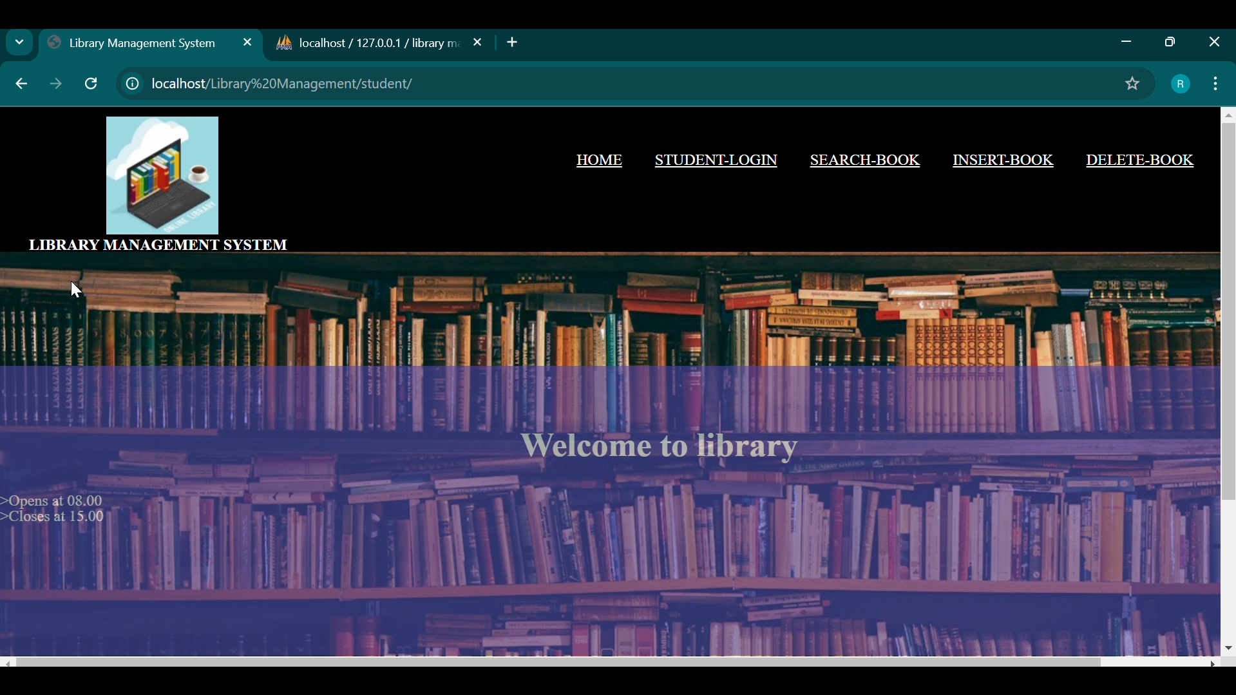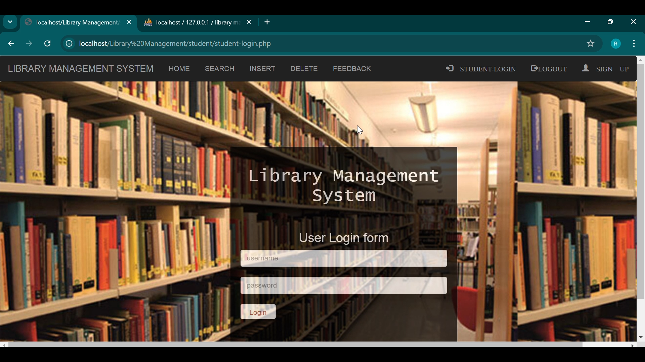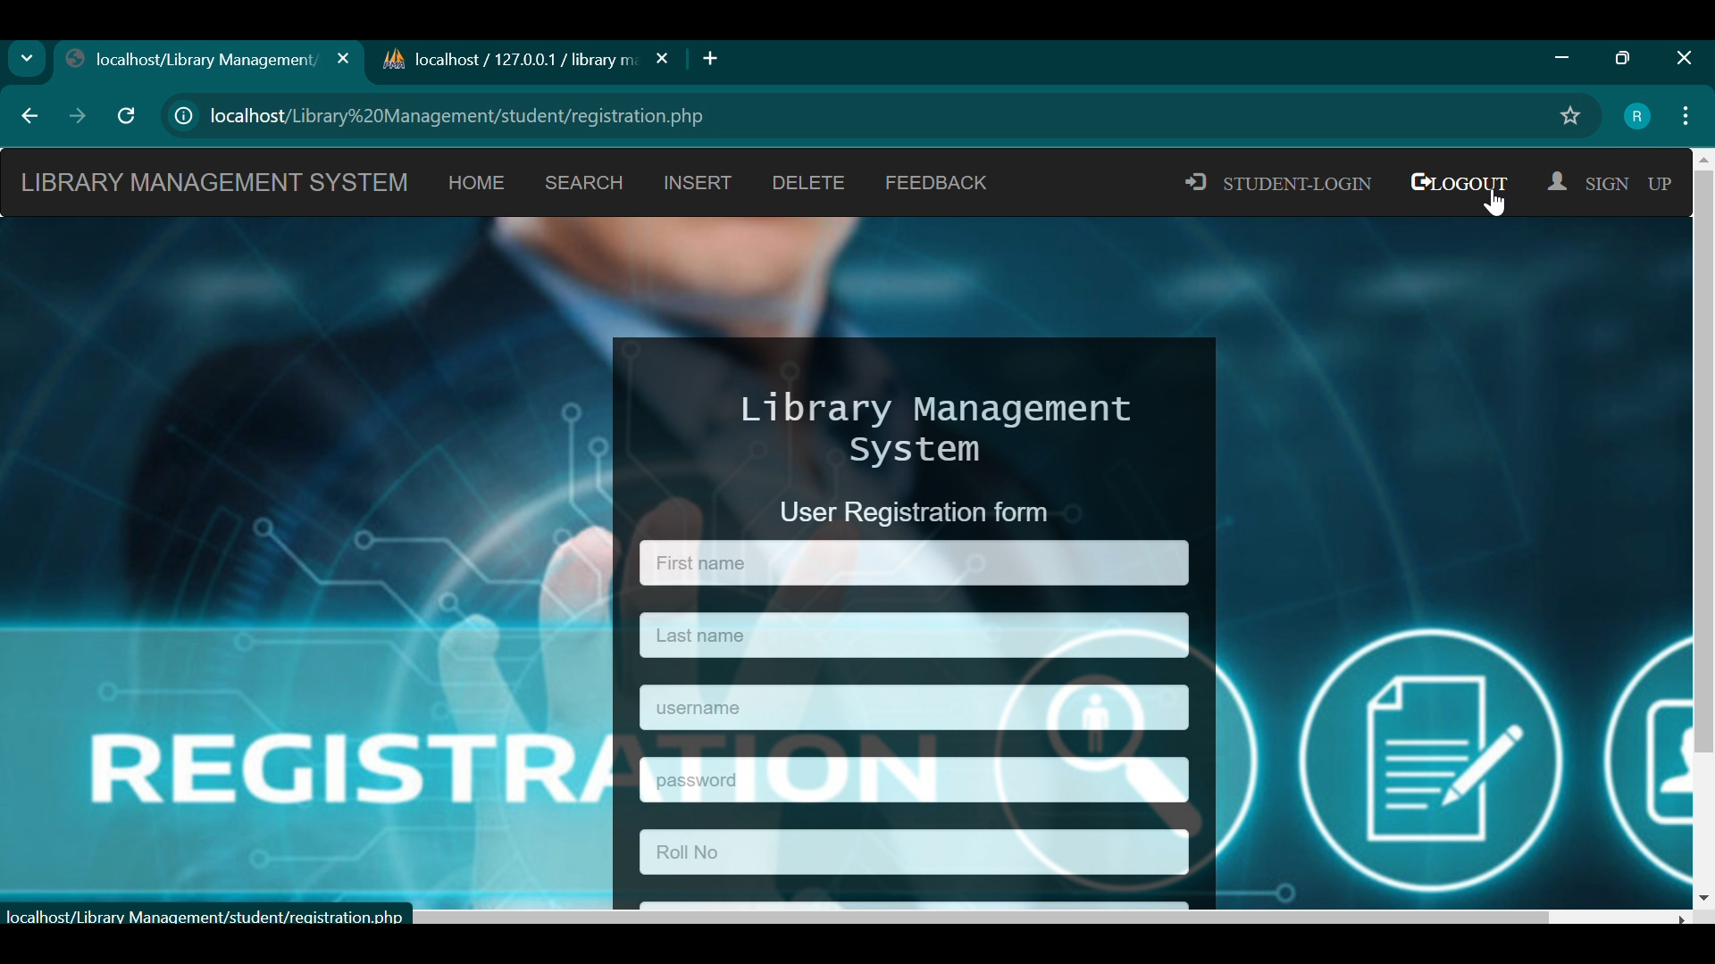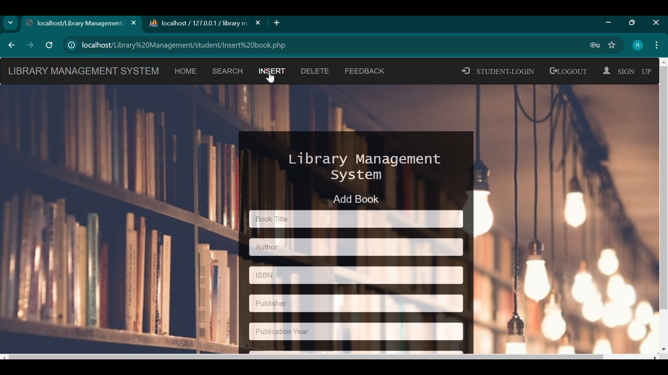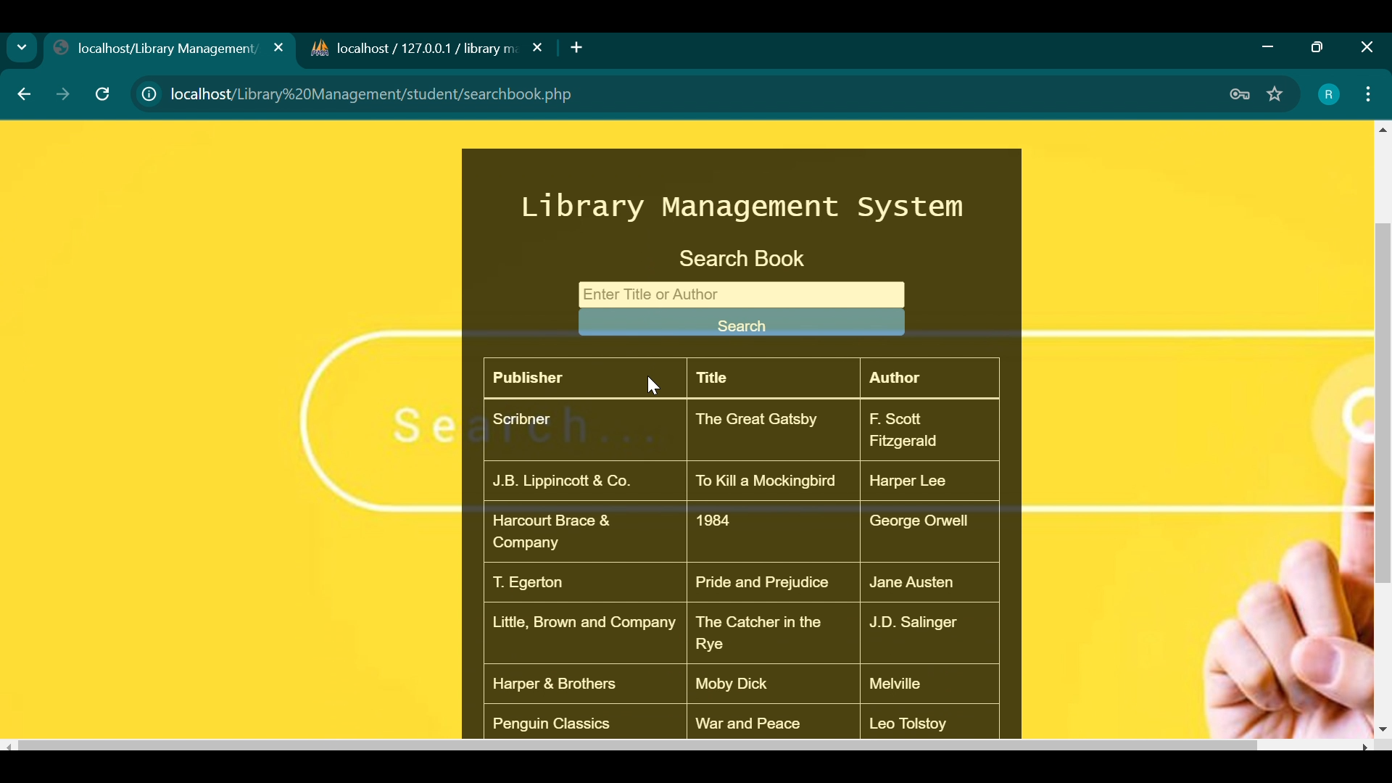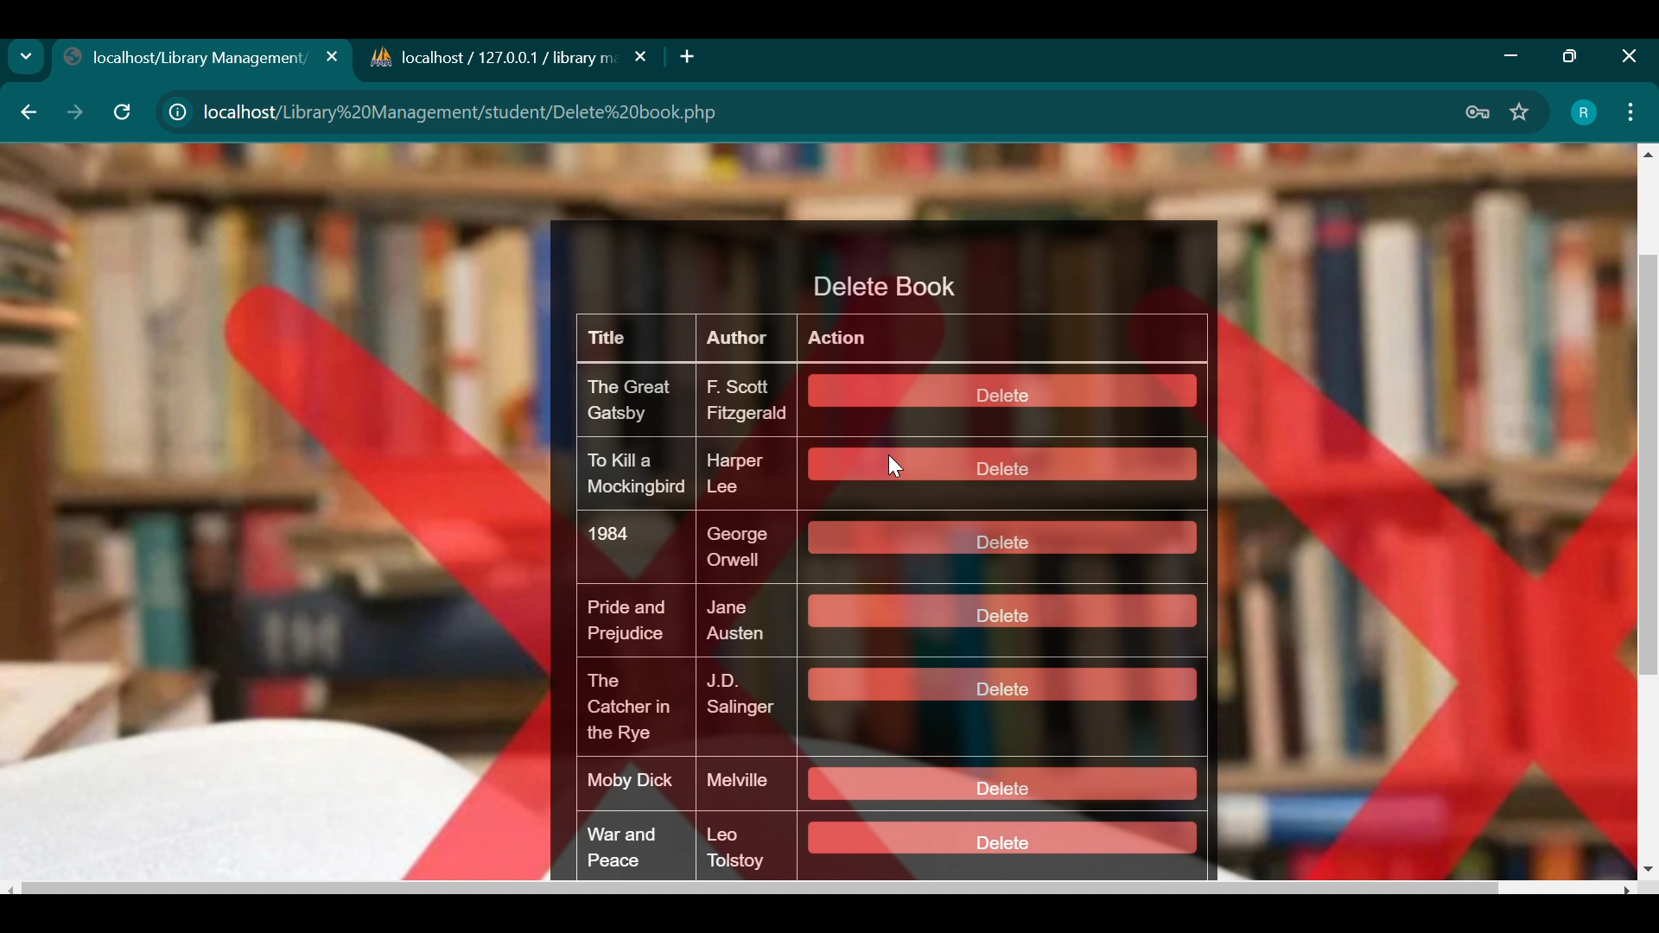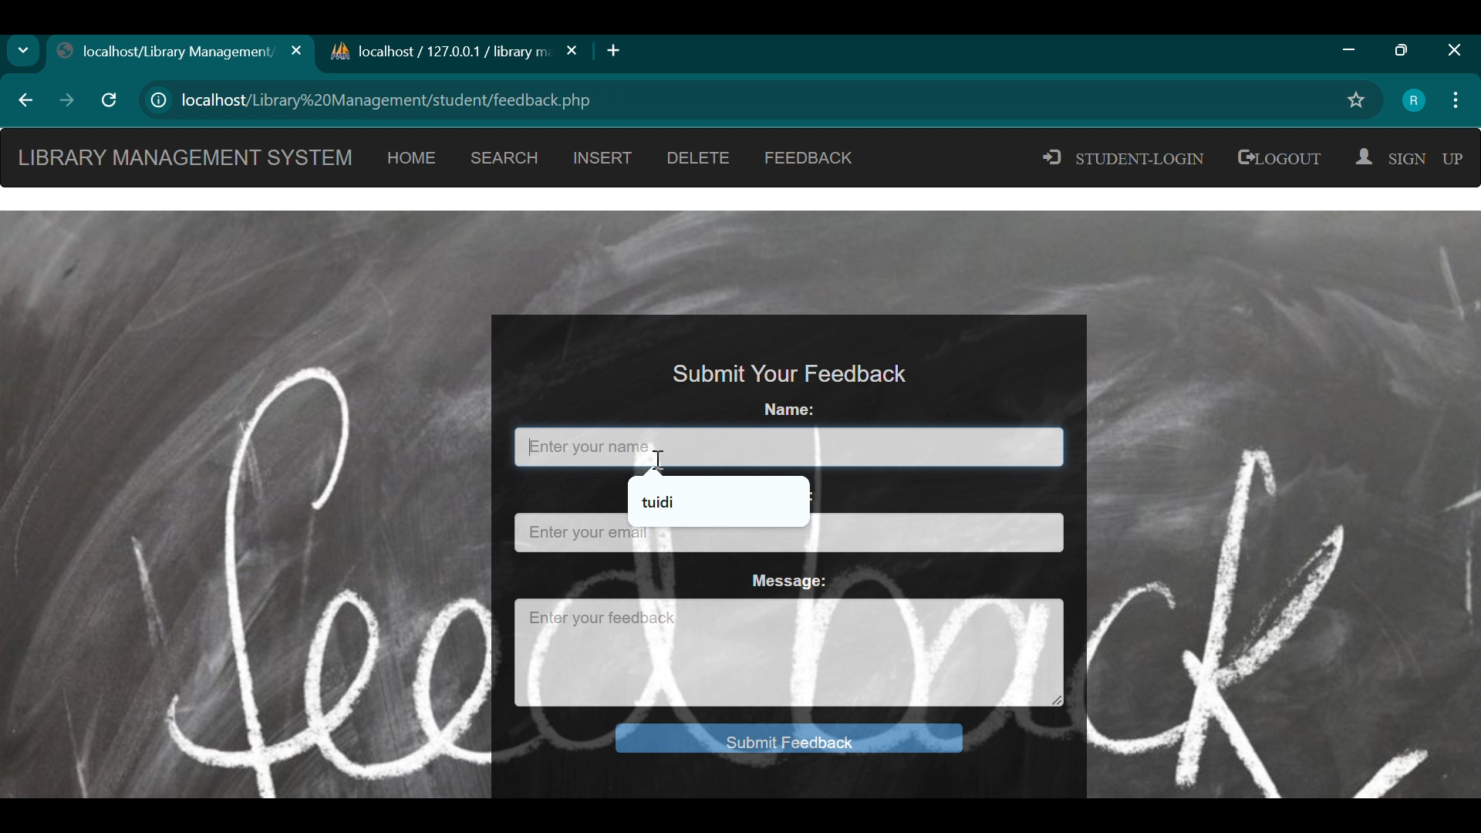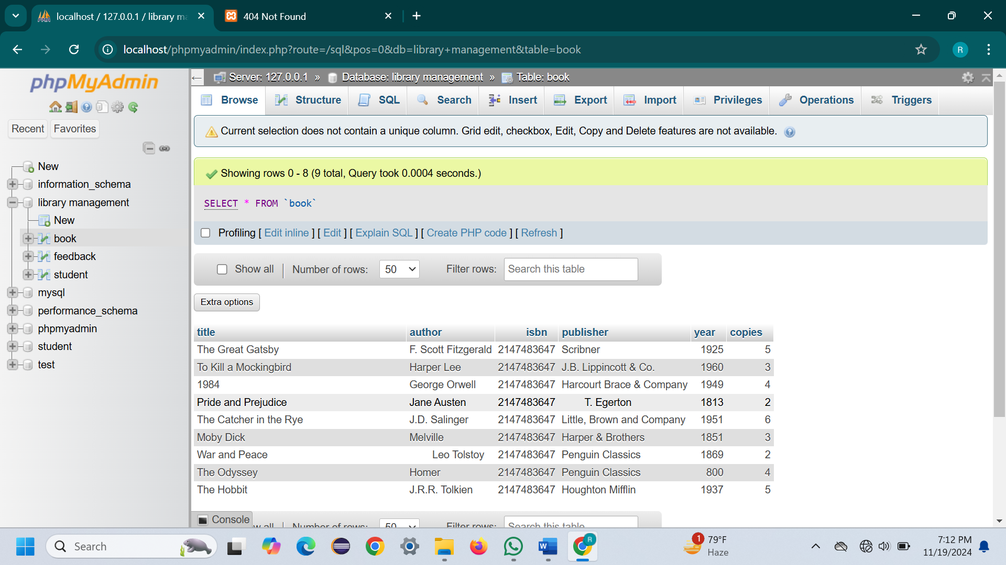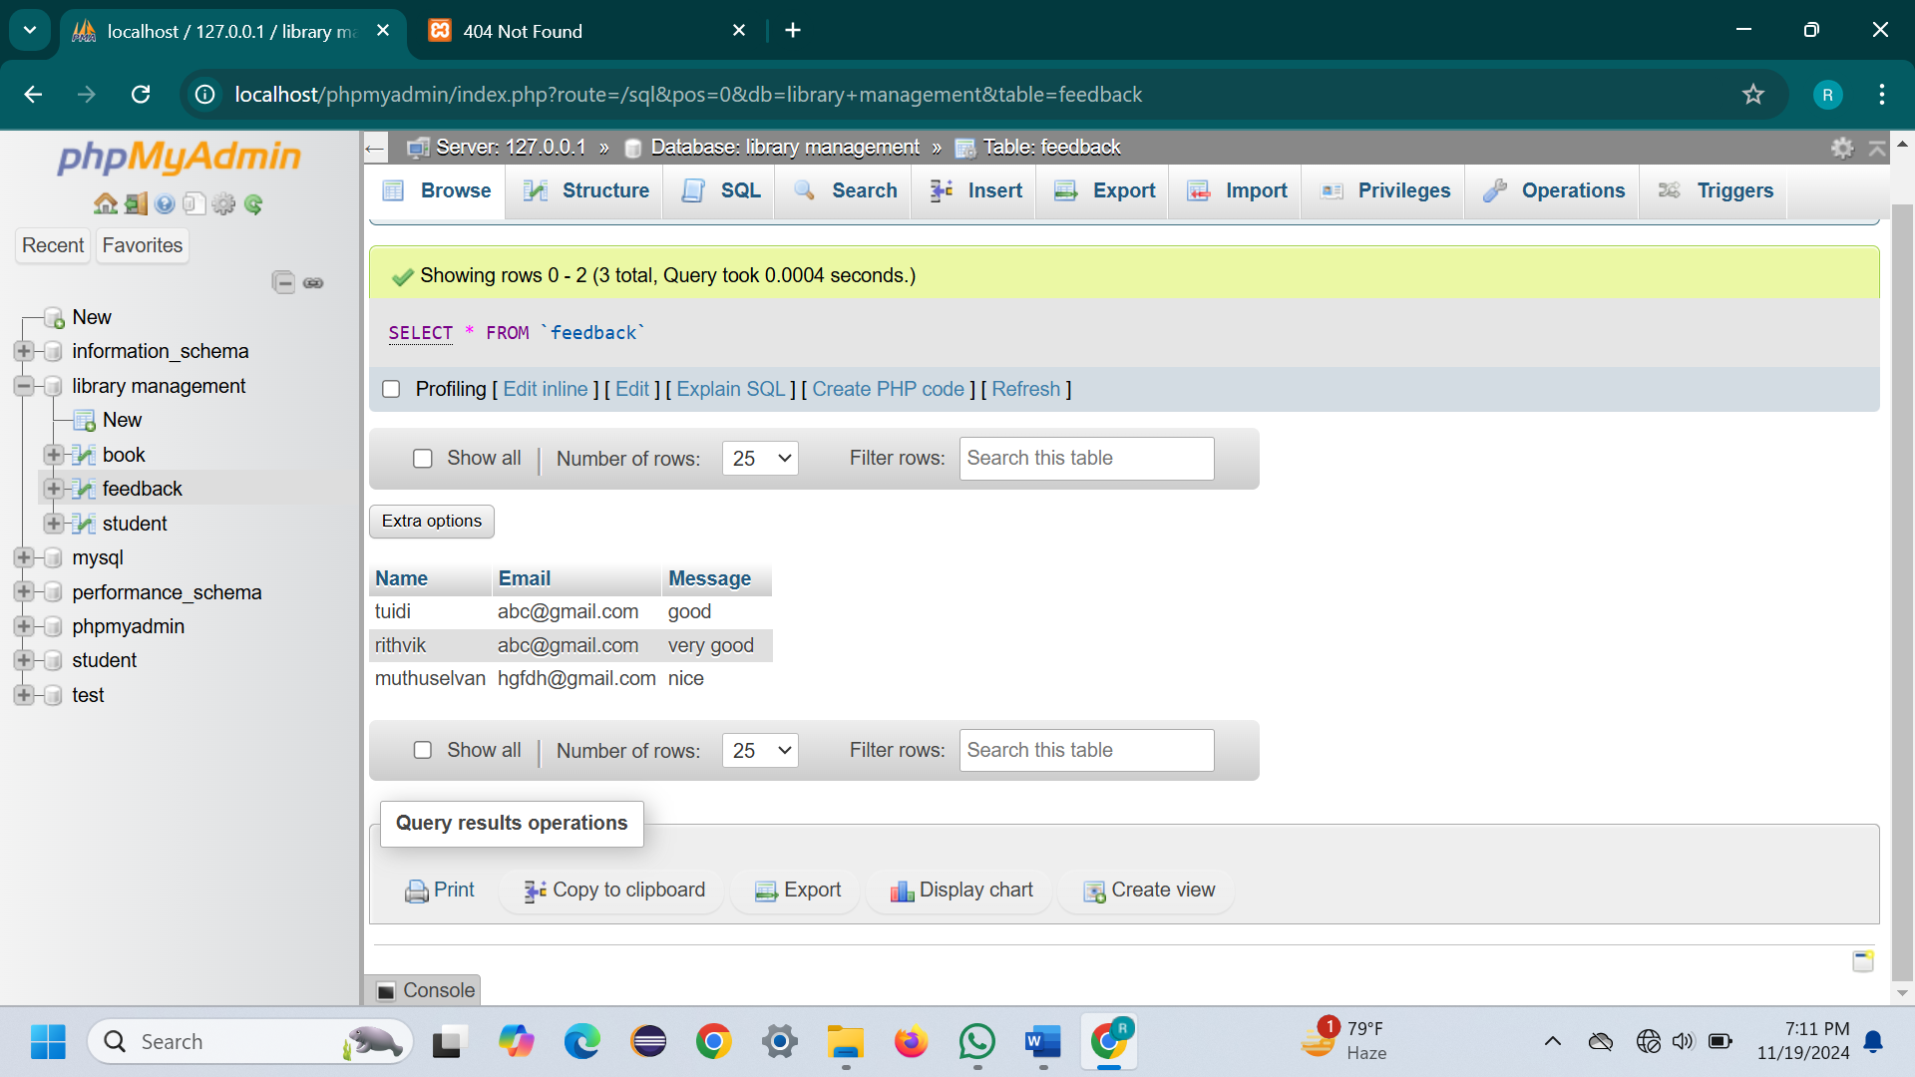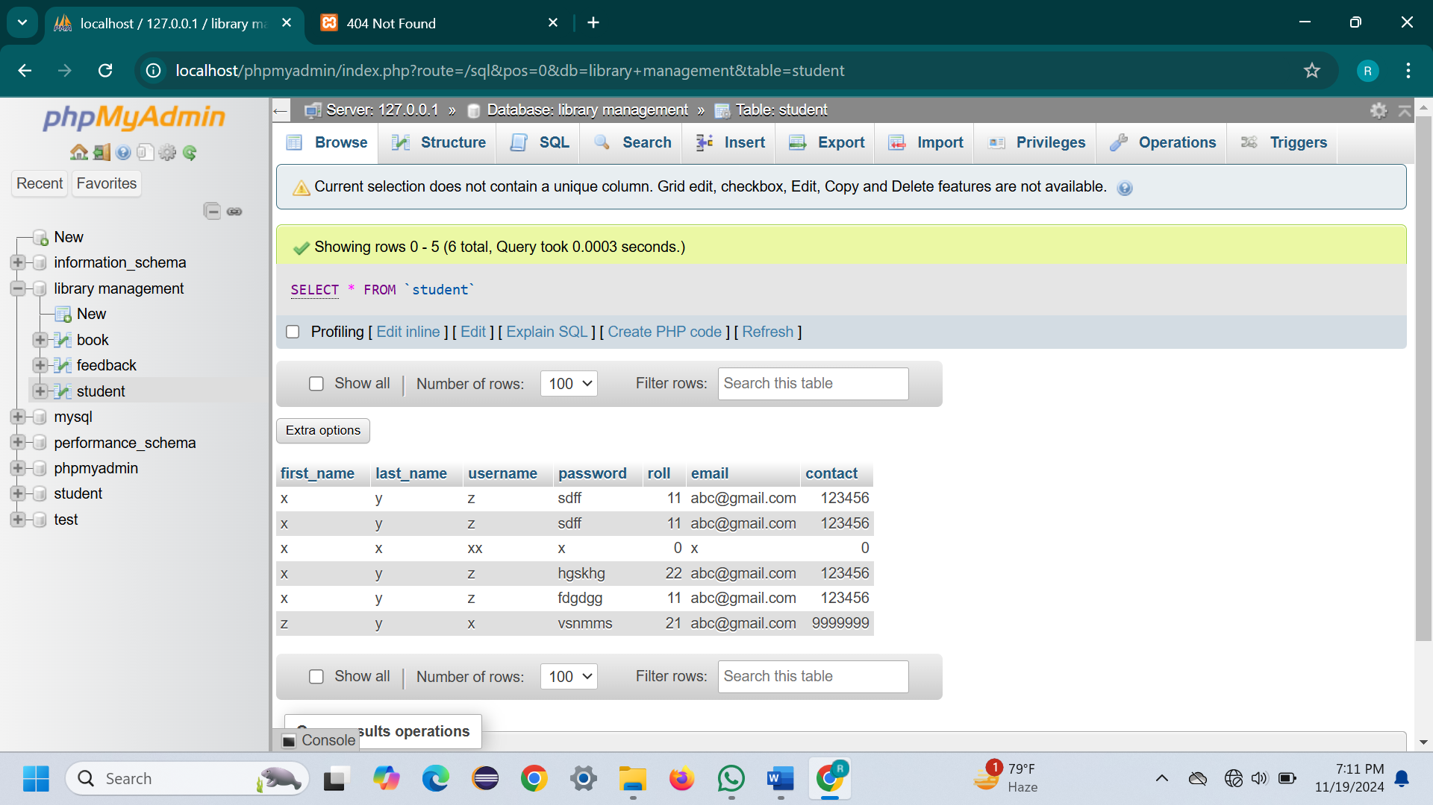

**9. Results and Analysis**

The implementation of the **Library Management System (LMS)** has demonstrated significant benefits in improving library operations and user experience. Key outcomes include:

**Enhanced Catalog Management**: The ability to manage books digitally has streamlined the cataloging process, reduced errors, and ensured real-time updates for book availability and status.

**Improved User Experience**: Users have expressed satisfaction with the intuitive search function and seamless book checkout and return process. The system's ability to track due dates and overdue books has significantly improved library access and organization.

**Operational Efficiency:** The real-time reporting and analytics features provide valuable insights into book usage patterns, overdue items, and user activity. This helps library staff make informed decisions on inventory management and service improvements.

**10.Conclusion**

The **Library Management System (LMS)** effectively addresses common challenges in library operations by streamlining book management, simplifying book checkouts and returns, and enhancing user access to library resources. By offering real-time reporting and interactive search features, the system improves efficiency, reduces manual errors, and provides valuable insights into book usage and user engagement. Future improvements could include integration with external book suppliers, a mobile app for easier access to library services, and advanced analytics to optimize book inventory and user satisfaction. This project demonstrates the power of technology in transforming traditional library operations, making them more efficient, user-friendly, and data-driven.